Solid Waste Management through public awareness and participation in Ichalkaranji City

Dr. M.B.Chougule
Associate Professor in Civil Engineering
Textile and Engineering Institute, Ichalkaranji, Maharashtra, India
Email- drmbchougule@gmail.com

1. Abstract
Solid waste is an outcome of different activities in the city. They are not new to mankind. When man was having the only occupation of hunting, the bone remains of the eaten animal were solid waste only. In agriculture many kind of undesirable grass which are harmful to crop growth; are removed in the process of cultivation, which become solid waste. This shows that ancient and medieval occupational patterns were also generating solid waste.
Ichalkaranji City is an industrial center. It has a sugar factory, 13 spinning and weaving mills, 173 sizing units, 190 winding units, 11 main processing houses, 81 hand processing unite, 70 dyeing and printing units, 10 foundries, 1.32,000 powerlooms and various supporting industrial unite. These various industrial unite leave out different types of solid waste. A sugar factory leaves bagasse, ash, the cotton industry leaves leather strikers and buffers, plastic buffers, cones, bags, sheets; packing jut, yarns in beam Vahifani’ and many such elements. Apart from this wastes, the cotton industry wastes out cotton fibers which pollute the air by remaining suspended in the air and then settle down to form cotton fiber waste. The cotton industry requires on large scale the use of cardboards and plastic for packing. This is ‘once use and throw’ type material and therefore, gets accumulated in large heaps every day. Apart from industrial centre Ichalkaranji city has 34 educational centres, 28 Banks and Financial Institutions, 5 Post Offices, 4 Telephone Exchanges, number of trading, transportation business, medical facilities providers and recreational center. The wastes coming out of these industries like used and tom stationary, chalkpit, dusterswrappers, bookcases, tyres, rubber tubes, broken glasses, fiber sheets, plastic automobile parts, medical waste, food and cold drink pickings, tissue papers also form a sizable part ofsolid wastes.
It is also observed that 5 fruit and vegetable markets, 1 slaughter house, 231 saloons and beauty parlors are also major contributors to the solid waste.
Huge amount of solid waste is generated from residential premises. If this solid waste is not properly disposed then it becomes nuisance to citizens.

2. Problem definition and purpose
The purpose of this study was to explore implementation strategies for fostering people’s participation and to understand role of Ichalkaranji municipal council in solid waste management in Ichalkaranji. Following are various points which are necessary to consider seriously.
- Due to improper disposal of municipal solid waste on the roads and immediate surroundings, biodegradable materials undergo decomposition producing foul smell and become a breeding ground for disease vectors.
- Industrial solid wastes are the source for toxic metals and hazardous wastes that affect soil characteristics and productivity of soils when they are dumped on the soil.Toxic substances may percolate into the ground and contaminate the groundwater.
- Burning of industrial or domestic wastes (cans, pesticides, plastics, radioactive materials and batteries) produce furans, dioxins and polychlorinated biphenyls that are harmful to human beings.
- During the process of collecting solid waste, the hazardous wastes usually mix with ordinary garbage and other flammable wastes making the disposal process even harder and risky.
- Following are the aims of this project -
- To understand the role of citizens and municipal council in solid waste management.
- To make necessary awareness in people through interviews.
- To communicate with municipal workers and motivate them to keep the city clean.

3. Importance of study
Solid wastes are hazard as it adversely affects both biotic as well as abiotic components of the environment. The disposal of solid waste should be a part of an integrated waste management plan. This project will throw some light on the causes and effects of solid waste pollution. Rapid population growth and urbanization in developing countries has led to people generating enormous quantities of solid waste and consequent environmental degradation. The waste is normally disposed in open dumps creating nuisance and environmental degradation. Solid wastes cause a major risk to public health and the environment. Management of solid wastes is important in order to minimize the adverse effects posed by their indiscriminate disposal.
Due to improper disposal of municipal solid waste on the roads and immediate surroundings, biodegradable materials undergo decomposition producing foul smell and become a breeding ground for disease vectors. Industrial solid wastes are the source for toxic metals and hazardous wastes that affect soil characteristics and productivity of soils when they are dumped on the soil. Toxic substances may percolate into the ground and contaminate the groundwater. Burning of industrial or domestic wastes (cans, pesticides, plastics, radioactive materials and batteries) produce furans, dioxins and polychlorinated biphenyls that are harmful to human beings. During the process of collecting solid waste, the hazardous wastes usually mix with ordinary garbage and other flammable wastes making the disposal process even harder and risky.

Different activities like food habit, living standard, and earning capacity of people creates solid waste in Indian villages. Booming economy, rapid technological development and impact of urban areas culture on rural area accelerated solid waste generation rate in villages. Now a day’s transportation facility is easily available for rural people, so they are well connected with urban areas causes the impact of living standard of urban people on the rural people. At village level waste is scattered everywhere in the living areas. To overcome above situation it is necessary to concentrate on problems related with effective management of waste, collection, recycling and utilization of waste material for energy generation at Indian village level. To find better option for village level solid waste management people participation is necessary.

4. Methodology
To understand the problem through IBPS diagram (Issue based problem study). The problem was studied thoroughly and root cause analysis was done.

IBPS diagram is prepared as below.

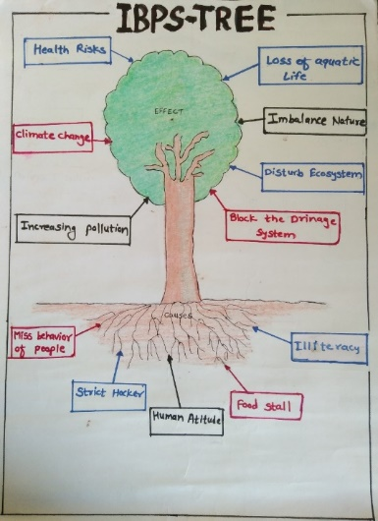

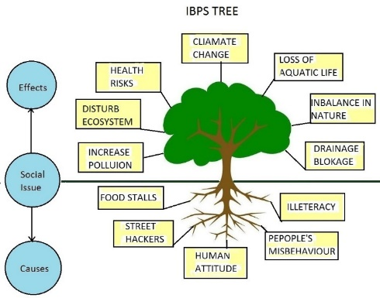

5. Survey at study area
Survey was made in the month of August (22/08/2017 to 23/08/2017). Various place were visited and it was found that most of the places are having solid waste scattered everywhere. Nuisance was caused because of this solid wastes. Municipal workers were ignored the cleaning.
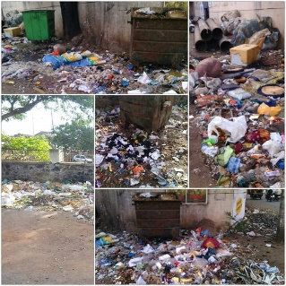

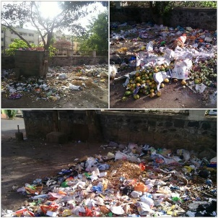

Also it was observed in the month of September (18/09/2017 to 19/09/2017) that local people surviving on solid waste generated. Some poor people collecting plastic and iron things from the waste for recycling purpose. At many places same situation was observed.

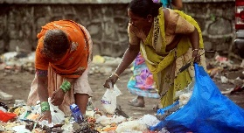
Request was made to municipal workers for cleaning of the areas in the month of October (12/10/2017 to 13/10/2017). Local people also involved the cleaning program. They also requested to remove the solid waste. Workers were also agreed to make the proper cleaning. Municipal workers also used insecticides to prevent viral diseases.

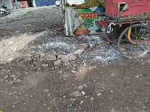
Municipal workers cleaned the area near all shops and carts. They removed dumps of solid waste and cleaned the area neatly.Cleaning of all gutters is carried out properly

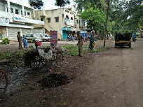

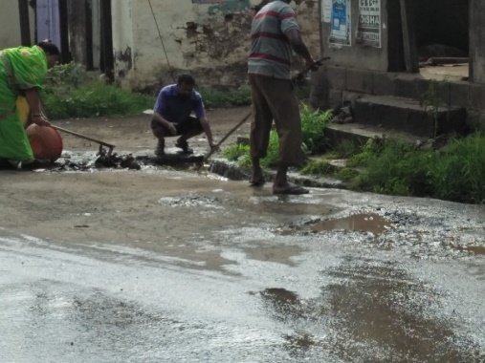
In the month of November (08/11/2017 to 09/11/2017) some good Initiatives were taken by Ichalkaranji Municipal Council. They made awareness in people regarding segregation of solid waste at source. They also informed to people that municipal council is going to provide two separate buckets in near future.

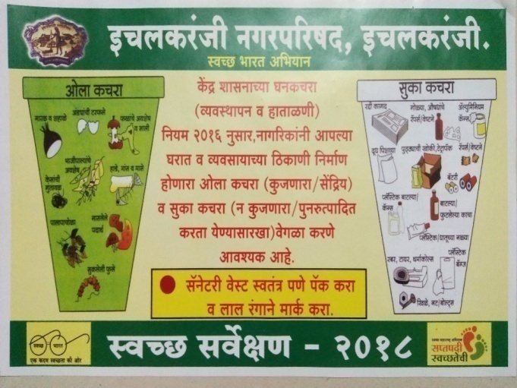

Municipal council is also provided information to citizens to install “Swachata” app on their mobile. This facility will help people to inform Municipal council regarding Solid waste generated and people can raise complaint online. People also receive the information whether cleaning is done or not. Municipal council is also providing “Ghanta Gadi” (Pick up Vehicle) to collect solid waste from door to door.

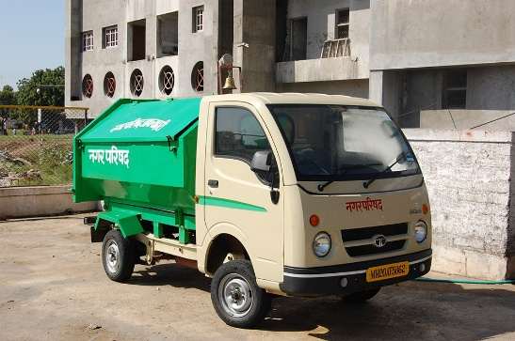

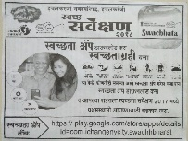
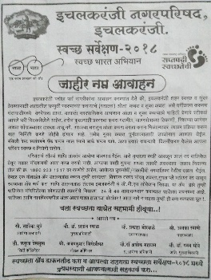

6. Observations
The major contributor is an average house holder in the city. The solid waste coming from every household is common everywhere and is called municipal waste. But even in this sector there is notable increment in these days. Increased use of plastic carry bags, packed foods, packed and branded ‘Kirana and Bhusari’ articles, paper packed medicines and plastic packed cosmetics, advent of frequently changing fashions and ‘use and throw’ culture in dresses, footwears, tapestry, wall furnishing have increased the contribution to this sector considerably.
When visited the study area following points found contributing solid waste generation.
- Food wastes of all kinds, cooked and uncooked, including eggshells, bones
- Flower and fruit wastes including juice peels and house-plant wastes
- House sweepings (not garden sweepings or yard waste: dispose on-site)
- Household Inert (sweepings/ashes)
- Paper and plastic, all kinds
- Cardboard and cartons
- Containers of all kinds excluding those containing hazardous materials
- Packaging of all kinds, Glass, Metals all kinds
- Rags, rubber, wood
- Foils, wrappings, pouches, sachets and tetrapaks (rinsed)
- Cassettes, computer diskettes, printer cartridges and electronic parts
- Discarded clothing, furniture and equipment

7. Analysis
When visited to study area it is found that Municipal solid waste is a heterogeneous mixture of paper, plastic, cloth, metal, glass, organic matter, etc. generated from households, commercial establishments, and markets. The proportion of different constituents of waste varies from season to season and place to place, depending on the lifestyle, food habits, standards of living, the extent of industrial and commercial activities in the area, and so on. Packaging materials are becoming an increasingly important component of municipal waste. There are many petty shops, hotels, bakeries, poultry chicken-meat selling centres, wedding halls and other commercial centres. The quantity of solid waste being generated from these commercial centres is large. With increasing industrialization and populations, however, solid waste generation has not only increased but its nature has also changed. Wastes from urban areas and industrial units contain diverse types of materials. Many of these discarded materials are often reusable and are often considered as a resource in another setting. ‘Solid waste management’ is a term that reflects efforts to manage society’s waste in a manner that meets public health and environmental concerns and encourages private & community attempts to reuse and recycle discarded materials.
8. Questionnaire for stakeholders:
Questions asked to stakeholders
- How do you dispose of your solid waste?
- Take it to the nearby secondary storage receptacle (Dustbin)
- B. Digging a hole around the house/in the village and bury or burn it.
- Throw it on an open space or on the street.
- Throw it in to the nearby river.
- Private collectors take it.
- Any other (specify) – Request made to municipal workers for regular cleaning.

9. SWOTAnalysis (Strength/Weakness/Opportunities/Threats)
1) To meet with shop keeper and all stakeholders and tell them importance of waste control.
SWOT Analysis | Helpful | Harmful
Internal | Strengths  *They may start controlling the waste. On site waste generation may reduce. | Weakness  *They may refuse to carry out such practices.
External | Opportunities  *Solid waste control at site only. | Threats  *oppose from stakeholders as considering it is Municipality’s work.

2) To meet the workers of municipal council and making request to keep regular cleaning.
SWOT Analysis | Helpful | Harmful
Internal | Strengths  *Regular cleaning may motivate the solid waste control. | Weakness  *Tentative acceptance of workers.
External | Opportunities  *Workers can motivate stakeholders to keep clean. | Threats  *Oppose from workers.

10. Conclusion
The quantity of solid waste being generated from these commercial centers is large. With increasingindustrialization and pollution, however solid waste generation has not only increased but its nature also has changed. Wastes from urban areas and industrial units contains diverse type of material. Many of these discarded materials are often reusable and are often considered as a resource in another setting. ‘Solid waste management’ is term that reflects efforts to manage society’s waste in a manner that meets public health and environmental concerns and encourages private and community attempts to reuse and recycle discarded materials.
Solid waste treatment and fuel generation plant can be erected in Ichalkaranji. Following benefits will be recognized through such project- Public litigation, diseases, nuisance & ground water pollution is avoided, Nuisance to neighbors is avoided, Use of natural energy resources, Project will be erected with ecofriendly and international standards, Flexibility in handling solid waste generated and Use of products generated can be involved in National integration program.

11. References
- Environmental Status report of Ichalkaranji city..
- Report by Ichalkaranji Cluster limited.
- Hydroair project report of solid waste management.
- Bharucha Erach, Enivironmental Studies, Universities press, hydrabad, 2005.
- Brunner R.C.Hazardous Waste Incineration, Mc Graw Hill Inc. ,1989.
- Cunningham, W.P.Cooper, T.h. Gorhani, E.and Hepworth, m.t..Envirinmental Encyclopedia, jaico publ. House, Mumbai,2001.
- Gleick, H.,1993, Water in crisis, Pacific Institute for Studies in Dev., Environmeny and Security. Stockholm Env. Institute. Oxford Univ. Press, 1993.
- Mckinney, M.L. and School. R.M. Env. science Systems and solutions 1996.

